**PSG Institute of Technology and Applied Research, Coimbatore**

**Department of Computer Science and Engineering**

**Class/ Sem : II- BE (CSE) / III Regulation : 2021**

**Subject Code & Name : CS3391 OBJECT ORIENTED PROGRAMMING**

**UNIT I**

**OBJECT-ORIENTED PROGRAMMING**

**Object-Oriented Programming** (OOP) is a programming language model organizedaround [objects](https://searchmicroservices.techtarget.com/definition/object) rather than actions and data. An object-oriented program can be characterized as data controlling access to code. Concepts of OOPS

* [Object](https://www.javatpoint.com/object-and-class-in-java)
* Class
* [Inheritance](https://www.javatpoint.com/inheritance-in-java)
* [Polymorphism](https://www.javatpoint.com/runtime-polymorphism-in-java)
* [Abstraction](https://www.javatpoint.com/abstract-class-in-java)
* [Encapsulation](https://www.javatpoint.com/encapsulation)

**OBJECT**

Object means a real word entity such as pen, chair, table etc. Any entity that has state and behavior is known as an object. Object can be defined as an instance of a class. An object contains an address and takes up some space in memory. Objects can communicate without knowing details of each other's data or code, the only necessary thing is that the type of message accepted and type of response returned by the objects.

An object has three characteristics:

* + state: represents data (value) of an object.
  + behavior: represents the behavior (functionality) of an object such as deposit, withdraw etc.
  + identity: Object identity is typically implemented via a unique ID. The value of the ID is not visible to the external user. But, it is used internally by the JVM to identify each object uniquely.

**CLASS**

Collection of objects is called class. It is a logical entity. A class can also be defined as a blueprint from which you can create an individual object. A class consists of Data members and methods.The primary purpose of a class is to hold data/information. The member functions determine the behavior of the class, i.e. provide a definition for supporting various operations on data held in the form of an object.Class doesn’t store any space.

**INHERITANCE**

Inheritance can be defined as the procedure or mechanism of acquiring all the properties and behavior of one class to another, i.e., acquiring the properties and behavior of child class from the parent class. When one object acquires all the properties and behaviours of another object, it is known as inheritance. It provides code reusability and establishes relationships between different classes. A class which inherits the properties is known as Child Class(sub-class or derived class) whereas a class whose properties are inherited is known as Parent class(super-class or base class). Types of inheritance in java: single, multilevel and hierarchical inheritance. Multiple and hybrid inheritance is supported through interface only.

**POLYMORPHISM**

When one task is performed by different ways i.e. known as polymorphism. For example: to convince the customer differently, to draw something e.g. shape or rectangle etc.

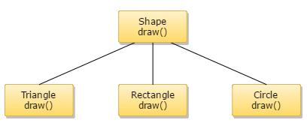

**Polymorphism is classified into two ways:**

**Method Overloading(Compile time Polymorphism)**

Method Overloading is a feature that allows a class to have two or more methods having the same name but the arguments passed to the methods are different. Compile time polymorphism refers to a process in which a call to an overloaded method is resolved at compile time rather than at run time.

**Method Overriding(Run time Polymorphism)**

If subclass (child class) has the same method as declared in the parent class, it is known as method overriding in java.In other words, If subclass provides the specific implementation of the method that has been provided by one of its parent class, it is known as method overriding.

**ABSTRACTION**

Abstraction is a process of hiding the implementation details and showing only functionality to the user. For example: phone call, we don't know the internal processing.In java, we use abstract class and interface to achieve abstraction.

**ENCAPSULATION**

**Encapsulation in java** is a process of wrapping code and data together into a single unit, forexample capsule i.e. mixed of several medicines.A java class is the example of encapsulation.

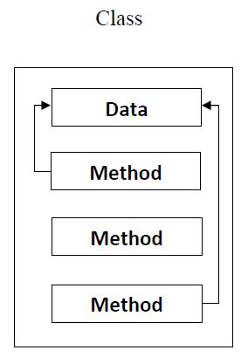

**DIFFERENCE BETWEEN PROCEDURE-ORIENTED AND OBJECT-ORIENTED PROGRAMMING**

|  |  |
| --- | --- |
| **Procedure-Oriented Programming (POP)** | **Object-Oriented Programming(OOP)** |
| In POP, program is divided into small parts  called **functions** | In OOP, program is divided into parts  called **objects**. |
| In POP,Importance is not given to data but to  functions as well as sequence of actions to be  done. | In OOP, Importance is given to the data rather  than procedures or functions because it works as  a **real world**. |
| POP follows **Top Down approach**. | OOP follows **Bottom Up approach**. |
| POP does not have any access specifier. | OOP has access specifiers named Public, Private,  Protected, etc. |
| In POP, Data can move freely from function to  function in the system. | In OOP, objects can move and communicate with  each other through member functions. |
| To add new data and function in POP is not so  easy. | OOP provides an easy way to add new data and  function. |
| In POP, Most function uses Global data for  sharing that can be accessed freely from function  to function in the system. | In OOP, data can not move easily from function  to function,it can be kept public or private so we  can control the access of data. |
| POP does not have any proper way for hiding  data so it is **less secure**. | OOP provides Data Hiding so provides **more**  **security**. |
| In POP, Overloading is not possible. | In OOP, overloading is possible in the form of  Function Overloading and Operator Overloading. |
| Example of POP are : C, VB, FORTRAN,  Pascal. | Example of OOP are : C++, JAVA, VB.NET,  C#.NET. |

**FEATURES OF JAVA**

The main objective of [Java programming](https://www.javatpoint.com/java-tutorial) language creation was to make it portable, simple and secure programming language. Apart from this, there are also some awesome features which play important role in the popularity of this language. The features of Java are also known as java buzzwords. A list of most important features of Java language are given below.

**Simple**

Java is very easy to learn and its syntax is simple, clean and easy to understand. According to Sun, Java language is a simple programming language because:

* Java syntax is based on C++ (so easier for programmers to learn it after C++).
* Java has removed many confusing and rarely-used features e.g. explicit pointers, operator overloading etc.
* There is no need to remove unreferenced objects because there is Automatic Garbage Collection in java.

Java is [object-oriented](https://www.javatpoint.com/java-oops-concepts) programming language. Everything in Java is an object. Object-oriented means we organize our software as a combination of different types of objects that incorporates both data and behaviour.

Object-oriented programming (OOPs) is a methodology that simplifies software development and

maintenance by providing some rules.

Basic concepts of OOPs are:

1. [Object](https://www.javatpoint.com/object-and-class-in-java)
2. Class
3. [Inheritance](https://www.javatpoint.com/inheritance-in-java)
4. [Polymorphism](https://www.javatpoint.com/runtime-polymorphism-in-java)
5. [Abstraction](https://www.javatpoint.com/abstract-class-in-java)
6. [Encapsulation](https://www.javatpoint.com/encapsulation)

**Platform Independent**

Java is platform independent because it is different from other languages like [C,](https://www.javatpoint.com/c-programming-language-tutorial) [C++](https://www.javatpoint.com/cpp-tutorial) etc. which are compiled into platform specific machines while Java is a write once, run anywhere language. A platform is the hardware or software environment in which a program runs.

There are two types of platforms software-based and hardware-based. Java provides software-based platform.

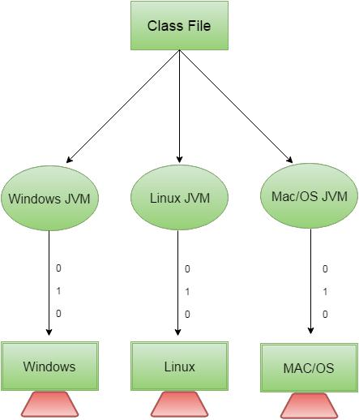

The Java platform differs from most other platforms in the sense that it is a software-based platform that runs on the top of other hardware-based platforms. It has two components:

1. Runtime Environment
2. API(Application Programming Interface)

Java code can be run on multiple platforms e.g. Windows, Linux, Sun Solaris, Mac/OS etc. Java code is compiled by the compiler and converted into bytecode. This bytecode is a platform-independent code because it can be run on multiple platforms i.e. Write Once and Run Anywhere(WORA).

**Secured**

Java is best known for its security. With Java, we can develop virus-free systems. Java is secured because:

1. No explicit pointer
2. Java Programs run inside virtual machine sandbox

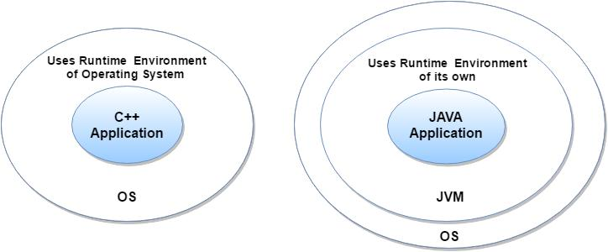

* **Classloader**: Classloader in Java is a part of the Java Runtime Environment(JRE) which is used todynamically load Java classes into the Java Virtual Machine. It adds security by separating the package for the classes of the local file system from those that are imported from network sources.
* **Bytecode Verifier**: It checks the code fragments for illegal code that can violate access right toobjects.
* **Security Manager**: It determines what resources a class can access such as reading and writing tothe local disk.

These security are provided by java language. Some security can also be provided by application developer through SSL, JAAS, Cryptography etc.

* Robust simply means strong. Java is robust because:
* It uses strong memory management.
* There are lack of pointers that avoids security problems.
* There is automatic garbage collection in java which runs on the Java Virtual Machine to get rid of objects which are not being used by a Java application anymore.
* There is exception handling and type checking mechanism in java. All these points makes java robust.

**Architecture-neutral**

Java is architecture neutral because there is no implementation dependent features e.g. size of primitive types is fixed.

In C programming, int data type occupies 2 bytes of memory for 32-bit architecture and 4 bytes of memory for 64-bit architecture. But in java, it occupies 4 bytes of memory for both 32 and 64 bit architectures.

**Portable**

Java is portable because it facilitates you to carry the java bytecode to any platform. It doesn't require any type of implementation.

**High-performance**

Java is faster than other traditional interpreted programming languages because Java bytecode is "close" to native code. It is still a little bit slower than a compiled language (e.g. C++). Java is an interpreted language that is why it is slower than compiled languages e.g. C, C++ etc.

**Distributed**

Java is distributed because it facilitates users to create distributed applications in java. RMI and EJB are used for creating distributed applications. This feature of Java makes us able to access files by calling the methods from any machine on the internet.

**Multi-threaded**

A thread is like a separate program, executing concurrently. We can write Java programs that deal with many tasks at once by defining multiple threads. The main advantage of multi-threading is that it doesn't occupy memory for each thread. It shares a common memory area. Threads are important for multi-media, Web applications etc.

**Dynamic**

Java is a dynamic language. It supports dynamic loading of classes. It means classes are loaded on demand. It also supports functions from its native languages i.e. C and C++.

Java supports dynamic compilation and automatic memory management (garbage collection).

**GARBAGE COLLECTION**

Objects are dynamically allocated by using the **new** operator, dynamically allocated objects must be manually released by use of a **delete** operator. Java takes a different approach; it handles deallocation automatically this is called garbage collection. When no references to an object exist, that object is assumed to be no longer needed, and the memory occupied by the object can be reclaimed. Garbage collection only occurs sporadically (if at all) during the execution of your program. It will not occur simply because one or more objects exist that are no longer used.

**THE JAVA ENVIRONMENT**

**JRE**

JRE is an acronym for Java Runtime Environment. It is also written as Java RTE. The Java Runtime Environment is a set of software tools which are used for developing java applications. It is used to provide runtime environment. It is the implementation of JVM. It physically exists. It contains set of libraries + other files that JVM uses at runtime.

Implementation of JVMs are also actively released by other companies besides Sun Micro Systems.

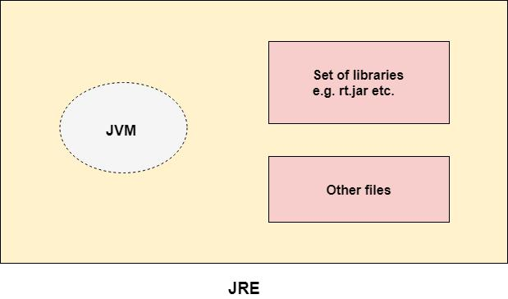

**JDK**

JDK is an acronym for Java Development Kit. The Java Development Kit (JDK) is a software development environment which is used to develop java applications and [applets.](https://www.javatpoint.com/java-applet) It physically exists. It contains JRE + development tools.

JDK is an implementation of any one of the below given Java Platforms released by Oracle corporation:

* Standard Edition Java Platform
* Enterprise Edition Java Platform
* Micro Edition Java Platform

The JDK contains a private Java Virtual Machine (JVM) and a few other resources such as an interpreter/loader (Java), a compiler (javac), an archiver (jar), a documentation generator (Javadoc) etc. to complete the development of a Java Application.

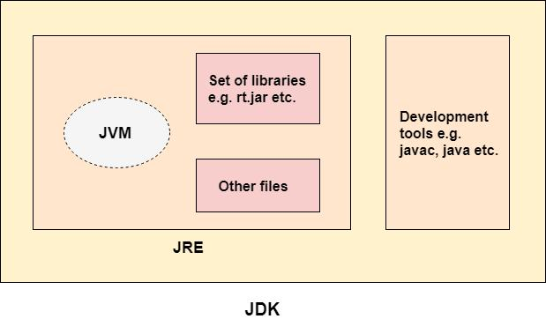

**JVM (Java Virtual Machine)**

JVM (Java Virtual Machine) is an abstract machine. It is a specification that provides runtime environment in which java bytecode can be executed.

JVMs are available for many hardware and software platforms (i.e. JVM is platform dependent).

The JVM performs following operation:

* Loads code
* Verifies code
* Executes code
* Provides runtime environment JVM provides definitions for the:
* Memory area
* Class file format
* Register set
* Garbage-collected heap
* Fatal error reporting etc.

**Internal Architecture of JVM**

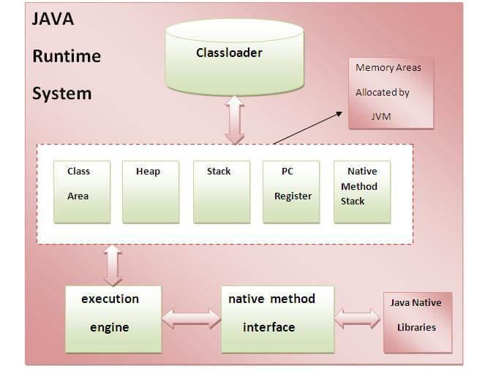

**1.Classloader**

Classloader is a subsystem of JVM that is used to load class files.

**2.Class(Method) Area**

Class(Method) Area stores per-class structures such as the runtime constant pool, field and method data, the code for methods.

**3.Heap**

It is the runtime data area in which objects are allocated.

**4.Stack**

Java Stack stores frames. It holds local variables and partial results, and plays a part in method invocation and return.

Each thread has a private JVM stack, created at the same time as thread.

A new frame is created each time a method is invoked. A frame is destroyed when its method invocation completes.

**5.Program Counter Register**

PC (program counter) register contains the address of the Java virtual machine instruction currently being executed.

**6. Native Method Stack**

It contains all the native methods used in the application.

**7. Execution Engine**

Contains a virtual processor, Interpreter to read bytecode stream then execute the instructions and Just-In-Time(JIT) compiler is used to improve the performance. JIT compiles parts of the byte code that have similar functionality at the same time, and hence reduces the amount of time needed for compilation. Here, the term "compiler" refers to a translator from the instruction set of a Java virtual machine (JVM) to the instruction set of a specific CPU.

**STRUCTURE OF JAVA PROGRAM**

**A first Simple Java Program**

class Simple

{

public static void main(String args[])

{

System.out.println("Java World");

}

}

**To compile:**

javac Simple.java

**To execute:**

java Simple

**class** keyword is used to declare a class in java.

**public** keyword is an access modifier which represents visibility, it means it is visible to all.

**static** is a keyword, if we declare any method as static, it is known as static method. The core advantage ofstatic method is that there is no need to create object to invoke the static method. The main method is executed by the JVM, so it doesn't require to create object to invoke the main method. So it saves memory. **void** is the return type of the method, it means it doesn't return any value. **main** represents the starting point of the program.

**String[] args** is used for command line argument.

**System.out.println()** is used print statement.

A program is written in JAVA, the javac compiles it. The result of the JAVA compiler is the .class file or the bytecode and not the machine native code (unlike C compiler).

The bytecode generated is a non-executable code and needs an interpreter to execute on a machine. This interpreter is the JVM and thus the Bytecode is executed by the JVM. And finally program runs to give the desired output.

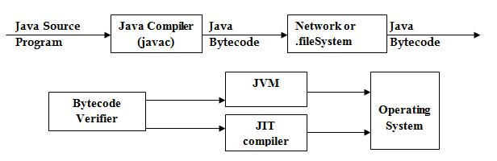

**DEFINING CLASSES IN JAVA**

The class is at the core of Java .A class is a template for an object, and an object is an instance of a class. A class is declared by use of the **class** keyword

**Syntax:**

class classname {

type instance-variable1;

type instance-variable2;

// ...

type instance-variableN;

type methodname1(parameter-list) {

* body of method

}

...

type methodnameN(parameter-list) {

* body of method

}

The data, or variables, defined within a **class** are called instance variables. The code is contained within methods. The methods and variables defined within a class are called members of the class. In most classes, the instance variables are acted upon and accessed by the methods defined for that class.

Variables defined within a class are called instance variables because each instance of the class (that is, each object of the class) contains its own copy of these variables. Thus, the data for one object is separate and unique from the data for another.

**A Simple Class**

class called **Box** that

defines three instance variables: **width**, **height**, and **depth**.

class Box {

double width;

double height;

double depth;

}

The new data type is called **Box**. This name is used to declare objects of type **Box**. The class declaration only creates a template. It does not create an actual object.

**To create a Box object**

Box mybox = new Box(); // create a Box object called mybox

**mybox** will be an instance of **Box**.

Each time you create an instance of a class, you are creating an object that contains its own copy of each instance variable defined by the class. To access these variables, you will use the dot (.) operator. The dot operator links the name of the object with the name of an instance variable.

**Example1:**

/* A program that uses the Box class.

Call this file BoxDemo.java

*/

class Box {

double width;

double height;

double depth;

}

* This class declares an object of type Box. class BoxDemo {

public static void main(String args[]) { Box mybox = new Box();

double vol;

* assign values to mybox's instance variables mybox.width = 10;

mybox.height = 0; mybox.depth = 15;

* compute volume of box

vol = mybox.width * mybox.height * mybox.depth;

System.out.println("Volume is " + vol);

}

}

**Output:**

Volume is 3000.0

**Example2:**

* This program declares two Box objects. class Box {

double width; double height; double depth;

}

class BoxDemo2 {

public static void main(String args[]) { Box mybox1 = new Box();

Box mybox2 = new Box(); double vol;

* assign values to mybox1's instance variables mybox1.width = 10;

mybox1.height = 0; mybox1.depth = 15;

/* assign different values to mybox2's instance variables */

mybox2.width = 3;

mybox2.height = 6;

mybox2.depth = 9;

// compute volume of first box

vol = mybox1.width * mybox1.height * mybox1.depth; System.out.println("Volume is " + vol); // compute volume of second box

vol = mybox2.width * mybox2.height * mybox2.depth; System.out.println("Volume is " + vol); }

}

**Output:**

Volume is 3000.0

Volume is 162.0

**Declaring Objects**

First, declare a variable of the class type. This variable does not define an object.Instead, it is simply a variable that can refer to an object.

Second, you must acquire an actual, physical copy of the object and assign it to that variable. This is done using the **new** operator. The **new** operator dynamically allocates (that is, allocates at run time) memory for an object and returns a reference to it. This reference is then stored in the variable. Thus, in Java, all class objects must be dynamically allocated.

**Syntax:**

Box mybox = new Box();

Box mybox; // declare reference to object

mybox = new Box(); // allocate a Box object

The first line declares **mybox** as a reference to an object of type **Box**. At this point, **mybox** does not yet refer to an actual object. The next line allocates an object and assigns a reference to it to **mybox**. After the second line executes, we can use **mybox** as if it were a **Box** object. But in reality, **mybox** simply holds, in essence, the memory address of the actual **Box** object.

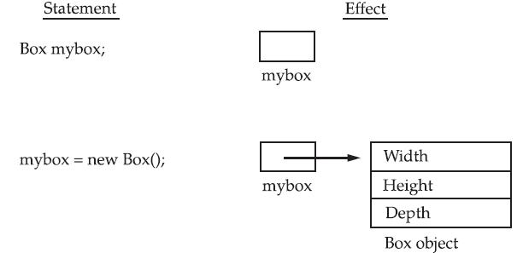

**Assigning Object Reference Variables**

**Syntax:**

Box b1 = new Box();

Box b2 = b1;

**b2** is being assigned a reference to a copy of the object referred to by **b1**. **b1** and **b2** will both refer to thesame object. The assignment of **b1** to **b2** did not allocate any memory or copy any part of the original

object. It simply makes **b2** refer to the same object as does **b1**. Thus, any changes made to the object through **b2** will affect the object to which **b1** is referring, since they are the same object.

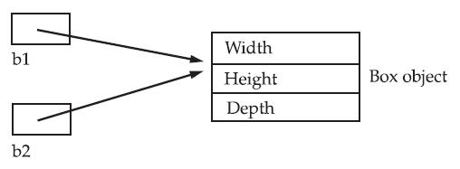

**CONSTRUCTORS**

* Constructors are special member functions whose task is to initialize the objects of its class.
* It is a special member function, it has the same as the class name.
* Java constructors are invoked when their objects are created. It is named such because, it constructs the value, that is provides data for the object and are used to initialize objects.
* Every class has a constructor when we don't explicitly declare a constructor for any java class the compiler creates a default constructor for that class which does not have any return type.
* The constructor in Java cannot be abstract, static, final or synchronized and these modifiers are not allowed for the constructor.

1. Default constructor (no-arg constructor)
2. Parameterized constructor

**Default constructor (no-arg constructor)**

A constructor having no parameter is known as default constructor and no-arg constructor.

**Example:**

/* Here, Box uses a constructor to initialize the

dimensions of a box.

*/

class Box {

double width;

double height;

double depth;

* This is the constructor for Box.

Box()

{ System.out.println("Constructing ox");

width = 10;

height = 10;

depth = 10;

}

* compute and return volume

double volume() {

return width * height * depth;

}

}

class BoxDemo6 {

public static void main(String args[]) {

* declare, allocate, and initialize Box objects

Box mybox1 = new Box();

Box mybox2 = new Box(); double vol;

* get volume of first box

vol = mybox1.volume();

System.out.println("Volume is " + vol);

* get volume of second box

vol = mybox2.volume();

System.out.println("Volume is " + vol);

}

}

**Output:**

Constructing Box

Constructing Box

Volume is 1000.0

Volume is 1000.0

**new Box( )** is calling the **Box( )** constructor. When the constructor for a class is not explicitly defined , thenJava creates a default constructor for the class. The default constructor automatically initializes all instance variables to their default values, which are zero, **null**, and **false**, for numeric types, reference types, and **boolean**, respectively.

**Parameterized Constructors**

A constructor which has a specific number of parameters is called parameterized constructor. Parameterized constructor is used to provide different values to the distinct objects.

**Example:**

/* Here, Box uses a parameterized constructor to

initialize the dimensions of a box.

*/

class Box {

double width;

double height;

double depth;

* This is the constructor for Box. Box(double w, double h, double d) { width = w;

height = h;

depth = d;

}

* compute and return volume double volume() {

return width * height * depth;

}

}

class BoxDemo7 {

public static void main(String args[]) {

* declare, allocate, and initialize Box objects

Box mybox1 = new Box(10, 20, 15);

Box mybox2 = new Box(3, 6, 9);

double vol;

* get volume of first box

vol = mybox1.volume();

System.out.println("Volume is " + vol);

* get volume of second box

vol = mybox2.volume();

System.out.println("Volume is " + vol);

}

}

**Output:**

Volume is 3000.0

Volume is 162.0

Box mybox1 = new Box(10, 20, 15);

The values 10, 20, and 15 are passed to the **Box( )** constructor when **new** creates the object. Thus, **mybox1**’s copy of **width**, **height**, and **depth** will contain the values 10, 20, and 15 respectively.

**Overloading Constructors**

**Example:**

/* Here, Box defines three constructors to initialize

the dimensions of a box various ways.

*/

class Box {

double width;

double height;

double depth;

* constructor used when all dimensions specified Box(double w, double h, double d) {

width = w; height = h; depth = d;

}

* constructor used when no dimensions specified Box() {

width = -1; // use -1 to indicate

height = -1; // an uninitialized

depth = -1; // box

}

* constructor used when cube is created Box(double len) {

width = height = depth = len;

}

* compute and return volume

double volume() {

return width * height * depth;

}

}

class OverloadCons

{

public static void main(String args[])

{

* create boxes using the various constructors

Box mybox1 = new Box(10, 20, 15);

Box mybox2 = new Box(); Box mycube = new Box(7); double vol;

* get volume of first box

vol = mybox1.volume();

System.out.println("Volume of mybox1 is " + vol);

* get volume of second box

vol = mybox2.volume();

System.out.println("Volume of mybox2 is " + vol);

* get volume of cube

vol = mycube.volume();

System.out.println("Volume of mycube is " + vol);

}

}

**Output:**

Volume of mybox1 is 3000.0

Volume of mybox2 is -1.0

Volume of mycube is 343.0

**METHODS**

**Syntax:**

type name(parameter-list) {

* body of method

}

* + type specifies the type of data returned by the method. This can be any valid type, including class types that you create.
  + If the method does not return a value, its return type must be **void**.
  + The name of the method is specified by name.
  + The parameter-list is a sequence of type and identifier pairs separated by commas. Parameters are essentially variables that receive the value of the arguments passed to the method when it is called. If the method has no parameters, then the parameter list will be empty.
  + Methods that have a return type other than **void** return a value to the calling routine using the following form of the **return** statement:

**Syntax:**

return value;

**Example:**

* This program includes a method inside the box class. class Box {

double width; double height; double depth;

* display volume of a box

void volume() {

System.out.print("Volume is ");

System.out.println(width * height * depth);

}}

class BoxDemo3 {

public static void main(String args[]) {

Box mybox1 = new Box();

Box mybox2 = new Box();

* assign values to mybox1's instance variables mybox1.width = 10;

mybox1.height = 20;

mybox1.depth = 15;

/* assign different values to mybox2's instance variables */ mybox2.width = 3;

mybox2.height = 6;

mybox2.depth = 9;

* display volume of first box mybox1.volume();
* display volume of second box mybox2.volume();

}

}

Output:

Volume is 3000.0 Volume is 162.0

The first line here invokes the **volume( )** method on **mybox1**. That is, it calls **volume( )** relative to the **mybox1** object, using the object’s name followed by the dot operator. Thus,the call to **mybox1.volume( )** displays the volume of the box defined by **mybox1**, and the call to **mybox2.volume( )** displays the volume of the box defined by **mybox2**. Each time **volume( )** is invoked, it displays the volume for the specified box.

**Returning a Value**

**Example:**

* Now, volume() returns the volume of a box.

class Box {

double width; double height; double depth;

* compute and return volume

double volume() {

return width * height * depth;

}

}

class BoxDemo4 {

public static void main(String args[]) {

Box mybox1 = new Box();

Box mybox2 = new Box();

double vol;

// assign values to mybox1's instance variables

mybox1.width = 10;

mybox1.height = 20;

mybox1.depth = 15;

/* assign different values to mybox2's instance variables */

mybox2.width = 3;

mybox2.height = 6;

mybox2.depth = 9;

* get volume of first box

vol = mybox1.volume();

System.out.println("Volume is " + vol);

* get volume of second box

vol = mybox2.volume();

System.out.println("Volume is " + vol);

}

}

**Output:**

Volume is 3000

Volume is 162

when **volume( )** is called, it is put on the right side of an assignment statement. On the left is a variable, in this case **vol**, that will receive the value returned by **volume( )**.

**Syntax:**

vol = mybox1.volume();

executes, the value of **mybox1.volume( )** is 3,000 and this value then is stored in **vol**.

There are two important things to understand about returning values:

* The type of data returned by a method must be compatible with the return type specified by the method.
* The variable receiving the value returned by a method (such as **vol**, in this case) must also be compatible with the return type specified for the method.

**Adding a Method That Takes Parameters**

**Example:**

* This program uses a parameterized method. class Box {

double width; double height; double depth;

* compute and return volume

double volume() {

return width * height * depth;

}

// sets dimensions of box

void setDim(double w, double h, double d) {

width = w;

height = h;

depth = d;

}

}

class BoxDemo5 {

public static void main(String args[]) {

Box mybox1 = new Box();

Box mybox2 = new Box();

double vol;

* initialize each box

mybox1.setDim(10, 20, 15);

mybox2.setDim(3, 6, 9);

* get volume of first box

vol = mybox1.volume();

System.out.println("Volume is " + vol);

* get volume of second box

vol = mybox2.volume();

System.out.println("Volume is " + vol);

}

}

**Output:**

Volume is 3000

Volume is 162

**The this Keyword**

this keyword is used to to refer to the object that invoked it. this can be used inside any method to refer to the current object. That is, this is always a reference to the object on which the method was invoked. this() can be used to invoke current class constructor.

**Syntax:**

Box(double w, double h, double d) {

this.width = w;

this.height = h;

this.depth = d;

}

**Example:**

class Student

{

int id;

String name;

student(int id, String name)

{

this.id = id;

this.name = name;

}

void display()

{

System.out.println(id+" "+name);

}

public static void main(String args[])

{

Student stud1 = new Student(01,"Tarun");

Student stud2 = new Student(02,"Barun");

stud1.display();

stud2.display();

}

}

**Output:**

1. Tarun
2. Barun

**Overloading Methods**

When two or more methods within the same class that have the same name, but their parameter declarations are different. The methods are said to be overloaded, and the process is referred to as method overloading. Method overloading is one of the ways that Java supports polymorphism. There are two ways to overload the method in java

* 1. By changing number of arguments
  2. By changing the data type

**Example:**

* Demonstrate method overloading.

class OverloadDemo {

void test() {

System.out.println("No parameters");

}

* Overload test for one integer parameter. void test(int a) { System.out.println("a: " + a);

}

* Overload test for two integer parameters. void test(int a, int b) {
* System.out.println("a and b: " + a + " " + b);

}

* Overload test for a double parameter double test(double a) { System.out.println("double a: " + a); return a*a;

}

}

class Overload {

public static void main(String args[]) { OverloadDemo ob = new OverloadDemo();

double result;

* call all versions of test()

ob.test();

ob.test(10);

ob.test(10, 20);

result = ob.test(123.25);

System.out.println("Result of ob.test(123.25): " + result);

}

}

**Output:**

No parameters

a: 10

a and b: 10 20

double a: 123.25

Result of ob.test(123.25): 15190.5625

**Method Overriding**

When a method in a subclass has the same name and type signature as a method in its superclass, then the method in the subclass is said to override the method in the superclass. When an overridden method is called from within its subclass, it will always refer to the version of that method defined by the subclass. The version of the method defined by the superclass will be hidden.

**Example:**

* Method overriding.
* class A {

int i, j;

A(int a, int b)

{ i = a;

j = b;

}

* display i and j
* void show() {

System.out.println("i and j: " + i + " " + j);

}

}

class B extends A

{ int k;

B(int a, int b, int c) { super(a, b);

k = c;

}

* display k – this overrides show() in A void show()

{

System.out.println("k: " + k);

}

}

class Override {

public static void main(String args[]) {

B subOb = new B(1, 2, 3); subOb.show(); // this calls show() in B

}

}

**Output**k: 3

When **show( )** is invoked on an object of type **B**, the version of **show( )** defined within **B** is used. That is, the

version of **show( )** inside **B** overrides the version declared in **A**. If you wish to access the superclass version

of an overridden method, you can do so by using **super**. For example, in this version of **B**, the superclass

version of **show( )** is invoked within the subclass’ version. This allows all instance variables to be displayed.

class B extends A {

int k;

B(int a, int b, int c) {

super(a, b);

k = c;

}

void show() {

super.show(); // this calls A's show()

System.out.println("k: " + k);

}

}

If you substitute this version of **A** into the previous program, you will see the following

**Output:**

i and j: 1 2

k: 3

Here, **super.show( )** calls the superclass version of **show( )**.

**ACCESS PROTECTION**

The access modifiers in java specifies accessibility (scope) of a data member, method, constructor or class.

There are 4 types of java access modifiers:

* 1. private
  2. default
  3. protected
  4. public

1. **Private Access Modifier**

The private access modifier is accessible only within class.

Simple example of private access modifier

In this example, we have created two classes A and Simple. A class contains private data member and

private method. We are accessing these private members from outside the class, so there is compile time

error.

class A{

private int data=40;

private void msg(){System.out.println("Hello java");}

}

public class Simple{

public static void main(String args[]){

A obj=new A();

System.out.println(obj.data);//Compile Time Error

obj.msg();//Compile Time Error

}

}

**Role of Private Constructor**

If you make any class constructor private, you cannot create the instance of that class from outside the class.

For example:

class A{

private A(){}//private constructor

void msg()

{System.out.println("Hello java");

}

}

public class Simple{

public static void main(String args[]){

A obj=new A();//Compile Time Error

}

}

If you make any class constructor private, you cannot create the instance of that class from outside the class.

For example:

class A{

private A(){}//private constructor

void msg(){System.out.println("Hello java");}

}

public class Simple{

public static void main(String args[]){

A obj=new A();//Compile Time Error

}

}

**2) Default Access Modifier**

If you don't use any modifier, it is treated as default bydefault. The default modifier is accessible only within package.

**Example:**

In this example, we have created two packages pack and mypack. We are accessing the A class from outside its package, since A class is not public, so it cannot be accessed from outside the package.

//save by A.java

package pack;

class A{

void msg(){System.out.println("Hello");}

}

//save by B.java

package mypack;

import pack.*;

class B{

public static void main(String args[]){

A obj = new A();//Compile Time Error

obj.msg();//Compile Time Error

}

}

In the above example, the scope of class A and its method msg() is default so it cannot be accessed from outside the package.

**3) Protected Access Modifier**

The protected access modifier is accessible within package and outside the package but through inheritance only.

The protected access modifier can be applied on the data member, method and constructor. It can't be applied on the class.

**Example:**

In this example, we have created the two packages pack and mypack. The A class of pack package is public, so can be accessed from outside the package. But msg method of this package is declared as protected, so it can be accessed from outside the class only through inheritance. //save by A.java

package pack;

public class A{

protected void msg()

{

System.out.println("Hello");}

}

//save by B.java

package mypack;

import pack.*;

class B extends A{

public static void main(String args[]){

B obj = new B();

obj.msg();

}

}

**Output:**

Hello

**4) Public Access Modifier**

The public access modifier is accessible everywhere. It has the widest scope among all other modifiers.

**Example:**

//save by A.java

package pack;

public class A{

public void msg()

{

System.out.println("Hello");

}

}

//save by B.java

package mypack;

import pack.*;

class B{

public static void main(String args[]){

A obj = new A();

obj.msg();

}

}

**Output:**

Hello

|  |  |  |  |  |
| --- | --- | --- | --- | --- |
| **Access Modifier** | **Within Class** | **Within Package** | **Outside Package**  **By Subclass Only** | **Outside Package** |
| **Private** | Y | N | N | N |
| **Default** | Y | Y | N | N |
| **Protected** | Y | Y | Y | N |
| **Public** | Y | Y | Y | Y |

**Java access modifiers with method overriding**

If you are overriding any method, overridden method (i.e. declared in subclass) must not be more restrictive.

class A{

protected void msg()

{

System.out.println("Hello java");}

}

public class Simple extends A{

void msg(){

System.out.println("Hello java");}//C.T.Error public static void main(String args[]){

Simple obj=new Simple();

obj.msg();

}

}

The default modifier is more restrictive than protected. That is why there is compile time error.

**STATIC MEMBERS**

Static is a non-access modifier in Java which is applicable for the following:

* 1. blocks
  2. variables
  3. methods
  4. nested classes

**Static blocks**

If you need to do computation in order to initialize your **static variables**, you can declare a static block that gets executed exactly once, when the class is first loaded.

**Example:**

* Java program to demonstrate use of static blocks

class Test

{

* static variable static int a = 10; static int b;
* static block static {

System.out.println("Static block initialized."); b = a * 4;

}

public static void main(String[] args)

{

System.out.println("from main");

System.out.println("Value of a : "+a);

System.out.println("Value of b : "+b);

}

}

**Output:**

Static block initialized.

from main

Value of a : 10

Value of b : 40

**Static variables**

When a variable is declared as static, then a single copy of variable is created and shared among all objects at class level. Static variables are, essentially, global variables. All instances of the class share the same static variable.

**Important points for static variables :-**

* + We can create static variables at class-level only.
  + static block and static variables are executed in order they are present in a program.

**Example:**

* Demonstrate static variables, methods, and blocks.

class UseStatic {

static int a = 3;

static int b;

static void meth(int x) {

System.out.println("x = " + x);

System.out.println("a = " + a);

System.out.println("b = " + b);

}

static {

System.out.println("Static block initialized.");

b = a * 4;

}

public static void main(String args[]) {

meth(42);

}

}

**Output:**

Static block initialized.

x = 42

a = 3

b = 12

**Static methods**

When a method is declared with static keyword, it is known as static method. When a member is declared **static**, it can be accessed before any objects of its class are created, and without reference to any object. Themost common example of a static method is main( ) method. Methods declared as static have several restrictions:

* They can only directly call other static methods.
* They can only directly access static data.
* They cannot refer to [**this**](https://www.geeksforgeeks.org/this-reference-in-java/) or [**super**](https://www.geeksforgeeks.org/super-keyword/) in any way.

**Syntax:** classname.method( )

**Example:**

//Inside main( ), the static method callme( ) and the static variable b are accessed through their class name

//StaticDemo.

class StaticDemo {

static int a = 42;

static int b = 99;

static void callme() {

System.out.println("a = " + a);

}

}

class StaticByName {

public static void main(String args[]) {

StaticDemo.callme();

System.out.println("b = " + StaticDemo.b);

}

}

**Output:**

a = 42

b = 99

**JAVA COMMENTS**

The java comments are statements that are not executed by the compiler and interpreter. The comments can

be used to provide information or explanation about the variable, method, class or any statement. It can also

be used to hide program code for specific time.

There are 3 types of comments in java.

* 1. Single Line Comment
  2. Multi Line Comment
  3. Documentation Comment

1. **Java Single Line Comment**

The single line comment is used to comment only one line.

**Syntax:**

//This is single line comment

**Example:**

public class CommentExample1

{

public static void main(String[] args)

{

int i=10;//Here, i is a variable

System.out.println(i);

}

}

**Output:**

10

**2) Java Multi Line Comment**

The multi line comment is used to comment multiple lines of code.

**Syntax:**

/*  Thisis

multi lin

ecomment*/

**Example:**

public class CommentExample2

{

public static void main(String[] args)

{

/* Let's declare and

print variable in java. */

int i=10;

System.out.println(i);

}

}

**Output:**

10

**3) Java Documentation Comment**

The documentation comment is used to create documentation API. To create documentation API, you need to use **javadoc tool.**

**Syntax:**

/**

This

is

documentation

comment

*/

**Example:**

/** The Calculator class provides methods to get addition and subtraction of given 2 numbers.*/

public class Calculator

{

/** The add() method returns addition of given numbers.*/ public static int add(int a, int b)

{

return a+b;

}

/** The sub() method returns subtraction of given numbers.*/ public static int sub(int a, int b)

{

return a-b;

}

}

This type of comment is used to produce an HTML file that documents your program. The documentation comment begins with a /** and ends with a */.

**DATATYPES IN JAVA**

Data types specify the different sizes and values that can be stored in the variable. There are two types of data types in Java:

1. **Primitive data types:** The primitive data types include Integer, Character, Boolean, and FloatingPoint.
2. **Non-primitive data types:** The non-primitive data types include Classes, Interfaces, and Arrays.

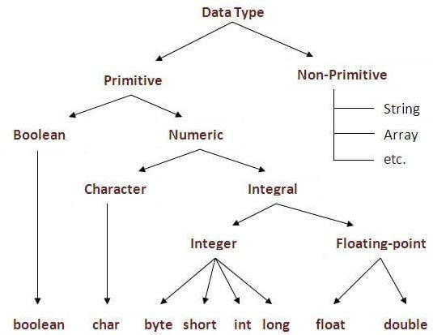

Java defines eight primitive types of data: byte, short, int, long, char, float, double, and boolean. These can be put in four groups:

* Integers This group includes byte, short, int, and long, which are for whole-valued signed numbers.
* Floating-point numbers This group includes float and double, which represent numbers with fractional precision.
* Characters This group includes char, which represents symbols in a character set, like letters and numbers.
* Boolean This group includes boolean, which is a special type for representing true/false values.

**Example :**

* Compute distance light travels using long variables. class Light {

public static void main(String args[]) { int lightspeed;

long days; long seconds; long distance;

* + approximate speed of light in miles per second lightspeed = 186000;

days = 1000; // specify number of days here seconds = days * 24 * 60 * 60; // convert to seconds distance = lightspeed * seconds; // compute distance System.out.print("In " + days); System.out.print(" days light will travel about "); System.out.println(distance + " miles.");

}

}

**Output:**

In 1000 days light will travel about 16070400000000 miles.

Clearly, the result could not have been held in an int variable.

**VARIABLES**

A variable is a container which holds the value and that can be changed durig the execution of the program. A variable is assigned with a datatype. Variable is a name of memory location. All the variables must be declared before they can be used. There are three types of variables in java: local variable, instance variable and static variable.

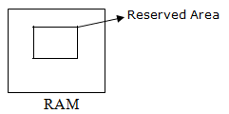

20

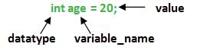

**1) Local Variable**

A variable defined within a block or method or constructor is called local variable.

* These variable are created when the block in entered or the function is called and destroyed after exiting from the block or when the call returns from the function.
* The scope of these variables exists only within the block in which the variable is declared. i.e. we can access these variable only within that block.

**Example:**

import java.io.*;

public class StudentDetails

{

public void StudentAge()

{ //local variable age int age = 0;

age = age + 5;

System.out.println("Student age is : " + age);

}

public static void main(String args[])

{

StudentDetails obj = new StudentDetails();

obj.StudentAge();

}

}

**Output:**

Student age is : 5

**2) Instance Variable**

Instance variables are non-static variables and are declared in a class outside any method, constructor or block.

* As instance variables are declared in a class, these variables are created when an object of the class is created and destroyed when the object is destroyed.
* Unlike local variables, we may use access specifiers for instance variables. If we do not specify any access specifier then the default access specifier will be used.

**Example:**

import java.io.*;

class Marks{

int m1;

int m2;

}

class MarksDemo

{

public static void main(String args[])

{ //first object

Marks obj1 = new Marks();

obj1.m1 = 50;

obj1.m2 = 80;

//second object

Marks obj2 = new Marks();

obj2.m1 = 80;

obj2.m2 = 60;

//displaying marks for first object

System.out.println("Marks for first object:");

System.out.println(obj1.m1);

System.out.println(obj1.m2);

//displaying marks for second object

System.out.println("Marks for second object:");

System.out.println(obj2.m1);

System.out.println(obj2.m2);

}}

**Output:**

Marks for first object:

50

80

Marks for second object:

80

60

**3) Static variable**

Static variables are also known as Class variables.

* These variables are declared similarly as instance variables, the difference is that static variables are declared using the static keyword within a class outside any method constructor or block.
* Unlike instance variables, we can only have one copy of a static variable per class irrespective of how many objects we create.
* Static variables are created at start of program execution and destroyed automatically when execution ends.

**Example:**

import java.io.*;

class Emp {

* static variable salary public static double salary;

public static String name = "Vijaya";

}

public class EmpDemo

{

public static void main(String args[]) {

//accessing static variable without object

Emp.salary = 1000;

System.out.println(Emp.name + "'s average salary:" + Emp.salary);

}}

**Output:**

Vijaya’s average salary:10000.0

**Difference between Instance variable and Static variable**

|  |  |
| --- | --- |
| **INSTANCE VARIABLE** | **STATIC VARIABLE** |
| Each object will have its **own copy** of instance | We can only have **one copy** of a static variable per |
| variable | class irrespective of how many objects we create. |
| Changes made in an instance variable using one | In case of static changes **will be reflected** in other |
| object will **not be reflected** in other objects as each | objects as static variables are common to all object |
| object has its own copy of instance variable | of a class. |
| We can access instance variables **through object** | Static Variables can be accessed **directly using class** |
| **references** | **name.** |
| Class Sample | Class Sample |
| { | { |
| int a; | static int a; |
| } | } |

**OPERATORS IN JAVA**

Java provides a rich set of operators to manipulate variables. We can divide all the Java operators into the following groups –

* Arithmetic Operators
* Increment and Decrement
* Bitwise Operators
* Relational Operators
* Boolean Operators
* Assignment Operator
* Ternary Operator

**Arithmetic Operators**

Arithmetic operators are used to manipulate mathematical expressions

**Operator Result**

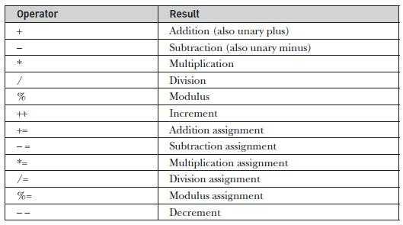

**Example:**

* Demonstrate the basic arithmetic operators. class BasicMath

{

public static void main(String args[])

{

* arithmetic using integers System.out.println("Integer Arithmetic"); int a = 1 + 1;

int b = a * 3; int c = b / 4; int d = c - a; int e = -d; System.out.println("a = " + a); System.out.println("b = " + b); System.out.println("c = " + c); System.out.println("d = " + d); System.out.println("e = " + e);

* arithmetic using doubles System.out.println("\nFloating Point Arithmetic"); double da = 1 + 1;

double db = da * 3; double dc = db / 4; double dd = dc - a; double de = -dd; System.out.println("da = " + da); System.out.println("db = " + db);

System.out.println("dc = " + dc);

System.out.println("dd = " + dd);

System.out.println("de = " + de);

}}

**Modulus Operator**

The modulus operator, **%**, returns the remainder of a division operation. It can be applied to floating-point types as well as integer types.

**Example:**

* Demonstrate the % operator. class Modulus {

public static void main(String args[]) { int x = 42;

double y = 42.25;

System.out.println("x mod 10 = " + x % 10); System.out.println("y mod 10 = " + y % 10);

}

}

**Output:**

x mod 10 = 2

y mod 10 = 2.25

**Arithmetic Compound Assignment Operators**

Java provides special operators that can be used to combine an arithmetic operation with an assignment. a = a + 4;

In Java, you can rewrite this statement as shown here:

a += 4;

**Syntax:**

var op= expression;

**Example:**

* Demonstrate several assignment operators. class OpEquals

{

public static void main(String args[])

{int a = 1; int b = 2; int c = 3; a += 5; b *= 4;

c += a * b;

c %= 6;

System.out.println("a = " + a);

System.out.println("b = " + b);

System.out.println("c = " + c);

}

}

**Output:**

a = 6

b = 8

c = 3

**Increment and Decrement Operators**

The ++ and the – – are Java’s increment and decrement operators. The increment operator increases its operand by one. The decrement operator decreases its operand by one.

**Example:**

* Demonstrate ++. class IncDec

{

public static void main(String args[])

{int a = 1; int b = 2; int c; int d;

c = ++b; d = a++; c++; System.out.println("a = " + a); System.out.println("b = " + b);

System.out.println("c = " + c);

System.out.println("d = " + d);

}

}

**Output:**

a = 2

b = 3

c = 4

d = 1

**Bitwise Operators**

Java defines several bitwise operators that can be applied to the integer types: **long**, **int**, **short**, **char**, and **byte**. These operators act upon the individual bits of their operands.

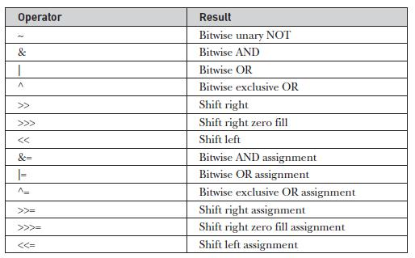

**Bitwise Logical Operators**

The bitwise logical operators are **&**, **|**, **^**, and **~**. the bitwise operators are applied to each individual bit within each operand.

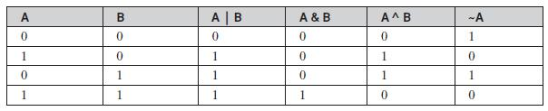

**Example:**

* Demonstrate the bitwise logical operators. class BitLogic

{

public static void main(String args[])

{

String binary[] = {"0000", "0001", "0010", "0011", "0100", "0101", "0110", "0111", "1000", "1001", "1010", "1011", "1100", "1101", "1110", "1111"};

int a = 3; // 0 + 2 + 1 or 0011 in binary int b = 6; // 4 + 2 + 0 or 0110 in binary int c = a | b;

ind = a & b; int e = a ^ b;

int f = (~a & b)|(a & ~b); int g = ~a & 0x0f; System.out.println(" a = " + binary[a]); System.out.println(" b = " + binary[b]); System.out.println(" a|b = " + binary[c]); System.out.println(" a&b = " + binary[d]); System.out.println(" a^b = " + binary[e]);

System.out.println("~a&b|a&~b = " + binary[f]);

System.out.println(" ~a = " + binary[g]);

}

}

**Output:**

a = 0011

b = 0110

a|b = 0111

a&b = 0010

a^b = 0101

~a&b|a&~b = 0101

~a = 1100

**Left Shift Operator**

The Java left shift operator << is used to shift all of the bits in a value to the left side of a specified number of times.

**Example:**

class OperatorExample

{

public static void main(String args[])

{

System.out.println(10<<2);//10*2^2=10*4=40

System.out.println(10<<3);//10*2^3=10*8=80

System.out.println(20<<2);//20*2^2=20*4=80

System.out.println(15<<4);//15*2^4=15*16=240

}

}

**Output:**

40

80

80

240

**Right Shift Operator**

The Java right shift operator >> is used to move left operands value to right by the number of bits specified by the right operand.

**Example:**

class OperatorExample

{

public static void main(String args[])

{

System.out.println(10>>2);//10/2^2=10/4=2

System.out.println(20>>2);//20/2^2=20/4=5

System.out.println(20>>3);//20/2^3=20/8=2

}

}

**Output:**

2

5

2

**Relational Operators**

The relational operators determine the relationship that one operand has to the other.Specifically, they determine equality and ordering. The outcome of these operations is a **boolean** value.

**Boolean Operators**

The Boolean logical operators shown here operate only on **boolean** operands. All of the binary logical operators combine two **boolean** values to form a resultant **boolean** value.

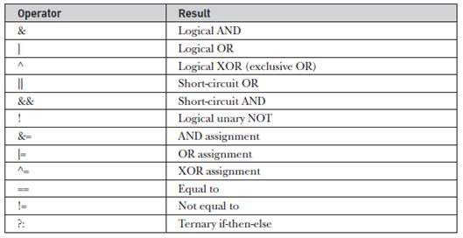

**Example:**

* Demonstrate the boolean logical operators. class BoolLogic

{

public static void main(String args[])

{

bolean a = true; boolean b = false; boolean c = a | b; boolean d= a & b; boolean e = a ^ b;

boolean f = (!a & b) | (a & !b); boolean g = !a; System.out.println(" a = " + a); System.out.println(" b = " + b); System.out.println(" a|b = " + c); System.out.println(" a&b = " + d); System.out.println(" a^b = " + e); System.out.println("!a&b|a&!b = " + f); System.out.println(" !a = " + g);

}

}

**Example:**

class OperatorExample

{

public static void main(String args[])

{

int a=10;

int b=5;

int c=20;

System.out.println(a<b&&a<c);//false && true = false System.out.println(a<b&a<c);//false & true = false }

}

**Output:**

false

false

**Assignment Operator**

The assignment operator is the single equal sign, =.

**Syntax:**

**var = expression;**

Here, the type of var must be compatible with the type of expression.

int x, y, z;

x = y = z = 100; // set x, y, and z to 100

This fragment sets the variables **x**, **y**, and **z** to 100 using a single statement.

**Ternary Operator**

Ternary operator in java is used as one liner replacement for if-then-else statement and used a lot in java programming. it is the only conditional operator which takes three operands.

**Syntax:**

expression1 ? expression2 : expression3

**Example:**

class OperatorExample

{

public static void main(String args[])

{

int a=2;

int b=5;

int min=(a<b)?a:b;

System.out.println(min);

}

}

**Output:**

2

**CONTROL STATEMENTS**

**Selection Statements in Java**

A programming language uses control statements to control the flow of execution of program based on certain conditions.

**Java’s Selection statements:**

* [if](https://www.geeksforgeeks.org/decision-making-javaif-else-switch-break-continue-jump/#if)
* [if-else](https://www.geeksforgeeks.org/decision-making-javaif-else-switch-break-continue-jump/#if-else)
* [nested-if](https://www.geeksforgeeks.org/decision-making-javaif-else-switch-break-continue-jump/#nested-if)
* [if-else-if](https://www.geeksforgeeks.org/decision-making-javaif-else-switch-break-continue-jump/#if-else-if)
* [switch-case](https://www.geeksforgeeks.org/decision-making-javaif-else-switch-break-continue-jump/#switch-case)
* [jump](https://www.geeksforgeeks.org/decision-making-javaif-else-switch-break-continue-jump/#jump) – break, continue, return

**if Statement**

if statement is the most simple decision making statement. It is used to decide whether a certain statement or block of statements will be executed or not that is if a certain condition is true then a block of statement is executed otherwise not.

**Syntax:**

if(condition)

{

//statements to execute if

//condition is true

}

Condition after evaluation will be either true or false. If the value is true then it will execute the block of statements under it. If there are no curly braces ‘{‘ and ‘}’ after **if( condition )** then by default if statement will consider the immediate one statement to be inside its block.

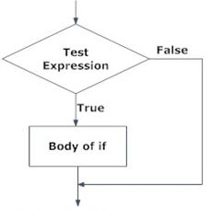

**Example:**

class IfSample

{

public static void main(String args[])

{

int x, y;

x = 10;

y = 20;

if(x < y)

System.out.println("x is less than y");

x = x * 2;

if(x == y)

System.out.println("x now equal to y");

x = x * 2;

if(x > y)

System.out.println("x now greater than y");

* this won't display anything if(x == y)

System.out.println("you won't see this");

}

}

**Output:**

x is less than y x now equal to y

x now greater than y

**if-else Statement**

The Java if-else statement also tests the condition. It executes the if block if condition is true else if it is false the else block is executed.

**Syntax:.**

If(condition)

{

//Executes this block if

//condition is true

}

else

{

//Executes this block if

//condition is false

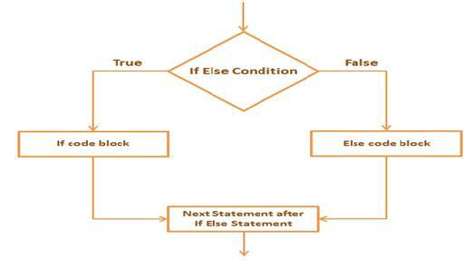}

**Example:**

public class IfElseExample

{

public static void main(String[] args)

{

int number=13;

if(number%2==0){

System.out.println("even number");

}else

{

System.out.println("odd number");

} } }

**Output:**

odd number

**Nested if Statement**

Nested if-else statements, is that using one if or else if statement inside another if or else if statement(s).

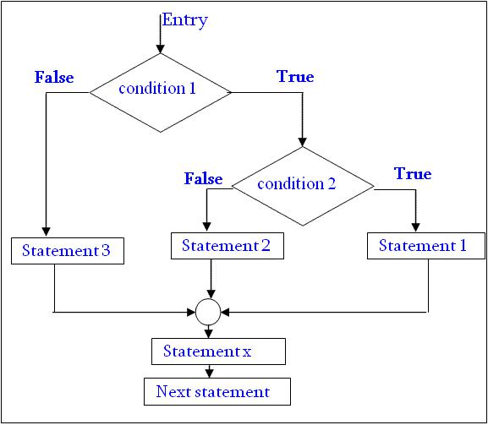

**Example:**

* Java program to illustrate nested-if statement class NestedIfDemo

{

public static void main(String args[])

{

int i = 10;

if (i == 10)

{

if (i < 15)

System.out.println("i is smaller than 15");

if (i < 12)

System.out.println("i is smaller than 12 too");

else

System.out.println("i is greater than 15");

}

}

}

**Output:**

i is smaller than 15

i is smaller than 12 too

**if-else-if ladder statement**

The if statements are executed from the top down. The conditions controlling the if is true, the statement associated with that if is executed, and the rest of the ladder is bypassed. If none of the conditions is true, then the final else statement will be executed.

**Syntax:**

if(condition)

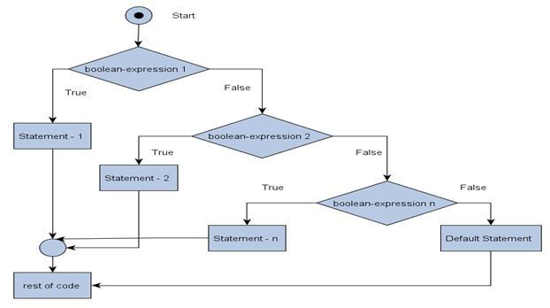statement;

else if(condition)

statement;

else if(condition)

statement;

.

.

else

statement;

**Example:**

public class IfElseIfExample {

public static void main(String[] args) {

int marks=65;

if(marks<50){

System.out.println("fail");

}

else if(marks>=50 && marks<60){

System.out.println("D grade");

}

else if(marks>=60 && marks<70){

System.out.println("C grade");

}

else if(marks>=70 && marks<80){

System.out.println("B grade");

}

else if(marks>=80 && marks<90){

System.out.println("A grade");

}else if(marks>=90 && marks<100){

System.out.println("A+ grade");

}else{

System.out.println("Invalid!");

}

}

}

**Output:**

C grade

**Switch Statements**

The **switch** statement is Java’s multiway branch statement. It provides an easy way to dispatch execution to different parts of your code based on the value of an expression.

**Syntax:**

switch (expression) {

case value1:

* statement sequence break;

case value2:

* statement sequence break;

.

.

case valueN :

* statement sequence break;

default:

* default statement sequence

}

**Example:**

* A simple example of the switch. class SampleSwitch {

public static void main(String args[])

{ for(int i=0; i<6; i++)

Switch(i)

{

Case 0:

System.out.println("i is zero."); break;

case 1:

System.out.println("i is one.");

break;

case 2:

System.out.println("i is two.");

break;

case 3:

System.out.println("i is three.");

break;

default:

System.out.println("i is greater than 3.");

}}}

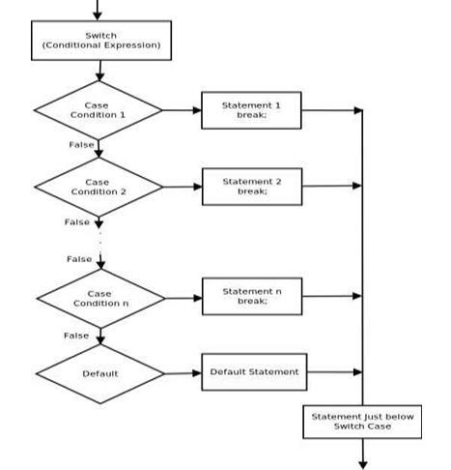**Output:**

i is zero.

i is one.

i is two.

i is three.

i is greater than 3.

i is greater than 3.

**ITERATIVE STATEMENTS**

In programming languages, loops are used to execute a set of instructions/functions repeatedly when some conditions become true. There are three types of loops in java.

* + while loop
  + do-while loop
  + For loop

**while loop**

A while loop is a control flow statement that allows code to be executed repeatedly based on a given Boolean condition. The while loop can be thought of as a repeating if statement.

**Syntax:**

while(condition) {

* body of loop

}

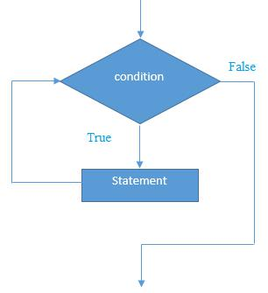

* + While loop starts with the checking of condition. If it evaluated to true, then the loop body statements are executed otherwise first statement following the loop is executed. It is called as Entry controlled loop.
  + Normally the statements contain an update value for the variable being processed for the next iteration.
  + When the condition becomes false, the loop terminates which marks the end of its life cycle.

**Example:**

* Demonstrate the while loop.

class While {

public static void main(String args[]) {

int n = 5;

while(n > 0) {

System.out.println("tick " + n);

n--;

}

}

}

**Output:**

tick 5

tick 4

tick 3

tick 2

tick 1

**do-while loop:**

do while loop checks for condition after executing the statements, and therefore it is called as Exit

Controlled Loop**.**

**Syntax:**

do {

// body of loop

} while (condition);

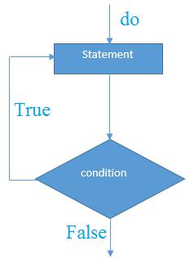

* do while loop starts with the execution of the statement(s). There is no checking of any condition for the first time.
* After the execution of the statements, and update of the variable value, the condition is checked for true or false value. If it is evaluated to true, next iteration of loop starts.
* When the condition becomes false, the loop terminates which marks the end of its life cycle.
* It is important to note that the do-while loop will execute its statements atleast once before any condition is checked, and therefore is an example of exit control loop.

**Example**

public class DoWhileExample {

public static void main(String[] args) {

int i=1;

do{

System.out.println(i);

i++;

}while(i<=5);

}

}

**Output:**

1

2

3

4

5

**for loop**

for loop provides a concise way of writing the loop structure. A for statement consumes the initialization, condition and increment/decrement in one line.

**Syntax**

for(initialization; condition; iteration) {

* body

}

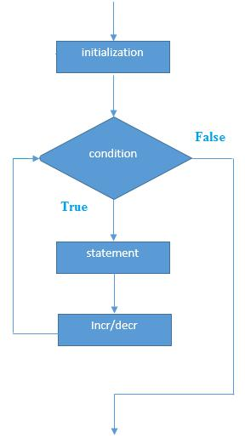

* **Initialization condition:** Here, we initialize the variable in use. It marks the start of a for loop. Analready declared variable can be used or a variable can be declared, local to loop only.
* **Testing Condition:** It is used for testing the exit condition for a loop. It must return a boolean value.It is also an **Entry Control Loop** as the condition is checked prior to the execution of the loop statements.
* **Statement execution:** Once the condition is evaluated to true, the statements in the loop body areexecuted.
* **Increment/ Decrement:** It is used for updating the variable for next iteration.
* **Loop termination:**When the condition becomes false, the loop terminates marking the end of its lifecycle.

**Example**

public class ForExample {

public static void main(String[] args) {

for(int i=1;i<=5;i++){

System.out.println(i);

}

} }

**Output:**

1

2

3

4

5

**for-each Loop**

The for-each loop is used to traverse array or collection in java. It is easier to use than simple for loop because we don't need to increment value and use subscript notation. It works on elements basis not index. It returns element one by one in the defined variable.

**Syntax:**

for(type itr-var : collection) statement-block

**Example:**

* Use a for-each style for loop. class ForEach {

public static void main(String args[])

{ int nums[] = { 1, 2, 3, 4, 5, 6, 7, 8, 9, 10 }; int sum = 0;

* use for-each style for to display and sum the values

for(int x : nums)

{

System.out.println("Value is: " + x); sum += x;

}

System.out.println("Summation: " + sum);

}

}

**Output:** Value is: 1 Value is: 2 Value is: 3 Value is: 4 Value is: 5 Value is: 6 Value is: 7 Value is: 8 Value is: 9 Value is: 10 Summation: 55

**Nested Loops**

Java allows loops to be nested. That is, one loop may be inside another.

**Example:**

* Loops may be nest

class Nested {

public static void main(String args[]) { int i, j;

for(i=0; i<10; i++)

{ for(j=i; j<10; j++)

System.out.print(".");

System.out.println();

}}}

**Output:**

..........

.........

........

.......

......

.....

....

...

..

.

**JUMP STATEMENTS**

**Java Break Statement**

* When a break statement is encountered inside a loop, the loop is immediately terminated and the program control resumes at the next statement following the loop.
* The Java break is used to break loop or switch statement. It breaks the current flow of the program at specified condition. In case of inner loop, it breaks only inner loop.

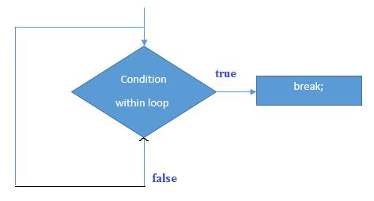

**Example:**

* Using break to exit a loop.

class BreakLoop {

public static void main(String args[]) { for(int i=0; i<100; i++) {

if(i == 10) break; // terminate loop if i is 10

System.out.println("i: " + i);

}

System.out.println("Loop complete.");

}

}

**Java Continue Statement**

* The continue statement is used in loop control structure when you need to immediately jump to the next iteration of the loop. It can be used with for loop or while loop.
* The Java continue statement is used to continue loop. It continues the current flow of the program and skips the remaining code at specified condition. In case of inner loop, it continues only inner loop.

**Example:**

* Demonstrate continue.

class Continue {

public static void main(String args[]) { for(int i=0; i<10; i++)

{ System.out.print(i + " ");

if (i%2 == 0) continue; System.out.println("");

}}}

This code uses the **%** operator to check if **i** is even. If it is, the loop continues without printing a newline.

**Return**

The last control statement is return. The return statement is used to explicitly return from a method. That is, it causes program control to transfer back to the caller of the method.

**Example:**

* Demonstrate return.

class Return {

public static void main(String args[])

{ boolean t = true;

System.out.println("Before the return.");

if(t) return; // return to caller

System.out.println("This won't execute.");

}

}

**Output:**

Before the return.

**ARRAYS**

* Array is a collection of similar type of elements that have contiguous memory location.
* In Java all arrays are dynamically allocated.
* Since arrays are objects in Java, we can find their length using member length.
* A Java array variable can also be declared like other variables with [] after the data type.
* The variables in the array are ordered and each have an index beginning from 0.
* Java array can be also be used as a static field, a local variable or a method parameter.
* The **size** of an array must be specified by an int value and not long or short.
* The direct superclass of an array type is [Object.](https://www.geeksforgeeks.org/object-class-in-java/)
* Every array type implements the interfaces [Cloneable](https://www.geeksforgeeks.org/marker-interface-java/) and [java.io.Serializable.](https://www.geeksforgeeks.org/serialization-in-java/)

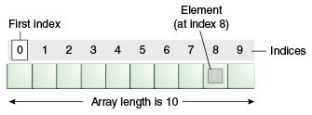

**Advantage of Java Array**

* **Code Optimization:** It makes the code optimized, we can retrieve or sort the data easily.
* **Random access:** We can get any data located at any index position.
* **Size Limit:** We can store only fixed size of elements in the array. It doesn't grow its size at runtime.To solve this problem, collection framework is used in java.

**Types of Array in java**

1. One- Dimensional Array
2. Multidimensional Array

**One-Dimensional Arrays**

An array is a group of like-typed variables that are referred to by a common name. An array declaration has two components: the type and the name. type declares the element type of the array. The element type determines the data type of each element that comprises the array. We can also create an array of other primitive data types like char, float, double..etc or user defined data type(objects of a class).Thus, the element type for the array determines what type of data the array will hold.

**Syntax:**

type var-name[ ];

**Instantiation of an Array in java**

array-var = new type [size];

**Example:**

class Testarray{

public static void main(String args[]){

int a[]=new int[5];//declaration and instantiation

a[0]=10;//initialization

a[1]=20;

a[2]=70;

a[3]=40;

a[4]=50;

//printing array

for(int i=0;i<a.length;i++)//length is the property of array

System.out.println(a[i]);

}}

**Output:**

10

20

70

40

50

**Declaration, Instantiation and Initialization of Java Array**

**Example:**

class Testarray1{

public static void main(String args[]){

int a[]={33,3,4,5};//declaration, instantiation and initialization //printing array

for(int i=0;i<a.length;i++)//length is the property of array

System.out.println(a[i]);

}}

**Output:**

33

3

4

5

**Passing Array to method in java**

We can pass the java array to method so that we can reuse the same logic on any array.

**Example:**

class Testarray2{

static void min(int arr[]){

int min=arr[0];

for(int i=1;i<arr.length;i++)

if(min>arr[i])

min=arr[i];

System.out.println(min);

}

public static void main(String args[]){

int a[]={33,3,4,5};

min(a);//passing array to method

}}

**Output:**

3

**Multidimensional Arrays**

Multidimensional arrays are arrays of arrays with each element of the array holding the reference of other array. These are also known as [Jagged Arrays.](https://www.geeksforgeeks.org/jagged-array-in-java/) A multidimensional array is created by appending one set of square brackets ([]) per dimension.

**Syntax:**

type var-name[ ][ ]=new type[row-size ][col-size ];

**Example:**

* Demonstrate a two-dimensional array.

class TwoDArray {

public static void main(String args[]) { int twoD[][]= new int[4][5];

int i, j, k = 0;

for(i=0; i<4; i++)

for(j=0; j<5; j++) {

twoD[i][j] = k; k++;

}

for(i=0; i<4; i++)

{

for(j=0; j<5; j++)

System.out.print(twoD[i][j] + " ");

System.out.println();

}}}

**Output:**

0 1 2 3 4

5 6 7 8 9

10 11 12 13 14

15 16 17 18 19

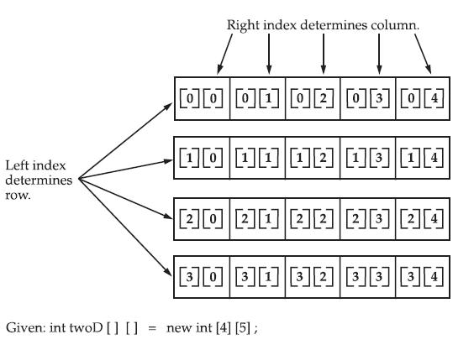

When you allocate memory for a multidimensional array, you need only specify the memory for the first (leftmost) dimension. You can allocate the remaining dimensions separately. For example, this following code allocates memory for the first dimension of **twoD** when it is declared. It allocates the second dimension manually.

**Syntax:**

int twoD[][] = new int[4][];

twoD[0] = new int[5];

twoD[1] = new int[5];

twoD[2] = new int[5];

twoD[3] = new int[5];

**Example:**

* Manually allocate differing size second dimensions.

class TwoDAgain {

public static void main(String args[])

{ int twoD[][] = new int[4][];

twoD[0] = new int[1];

twoD[1] = new int[2];

twoD[2] = new int[3];

twoD[3] = new int[4];

int i, j, k = 0;

for(i=0; i<4; i++)

for(j=0; j<i+1; j++)

{ twoD[i][j] = k;

k++;}

for(i=0; i<4; i++) { for(j=0; j<i+1; j++)

System.out.print(twoD[i][j] + " ");

System.out.println();

}}}

**Output:**

0

1 2

3 4 5

6 7 8 9

The array created by this program looks like this:

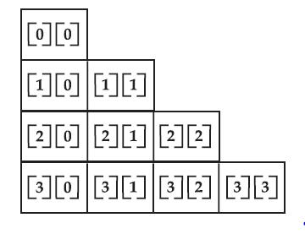

**Comments in Java**

In a program, comments take part in making the program become more human readable by placing the detail of code involved and proper use of comments makes maintenance easier and finding bugs easily. Comments are ignored by the compiler while compiling a code.

In Java there are three types of comments:

1. Single – line comments.
2. Multi – line comments.
3. Documentation comments.

**Single-line Comments**

A beginner level programmer uses mostly single-line comments for describing the code functionality. Its the most easiest typed comments.  
Syntax:

//Comments here( Text in this line only is considered as comment )

Example:

filter_none

edit

play_arrow

brightness_4

|  |
| --- |
| //Java program to show single line comments  class Scomment  {      public static void main(String args[])      {           // Single line comment here           System.out.println("Single line comment above");      }  } |

**Multi-line Comments**

To describe a full method in a code or a complex snippet single line comments can be tedious to write, since we have to give ‘//’ at every line. So to overcome this multi line comments can be used.  
Syntax:

/*Comment starts

continues

continues

.

.

.

Commnent ends*/

Example:

filter_none

edit

play_arrow

brightness_4

|  |
| --- |
| //Java program to show multi line comments  class Scomment  {      public static void main(String args[])      {          System.out.println("Multi line comments below");          /*Comment line 1            Comment line 2            Comment line 3*/      }  } |

We can also accomplish single line comments by using the above syntax as shown below:

/*Comment line 1*/

**Documentation Comments**

This type of comments are used generally when writing code for a project/software package, since it helps to generate a documentation page for reference, which can be used for getting information about methods present, its parameters, etc.  
For example <http://docs.oracle.com/javase/7/docs/api/java/util/Scanner.html> is an auto generated documentation page which is generated by using documentation comments and a javadoc tool for processing the comments.

**Syntax:**

/**Comment start

*

*tags are used in order to specify a parameter

*or method or heading

*HTML tags can also be used

*such as <h1>

*

*comment ends*/

Available tags to use:

|  |  |  |
| --- | --- | --- |
| **TAG** | **DESCRIPTION** | **SYNTAX** |
| @author | Adds the author of a class. | @author name-text |
| {@code} | Displays text in code font without interpreting the text as HTML markup or nested javadoc tags. | {@code text} |
| {@docRoot} | Represents the relative path to the generated document’s root directory from any generated page. | {@docRoot} |
| @deprecated | Adds a comment indicating that this API should no longer be used. | @deprecated deprecatedtext |
| @exception | Adds a **Throws** subheading to the generated documentation, with the classname and description text. | @exception class-name description |
| {@inheritDoc} | Inherits a comment from the **nearest**inheritable class or implementable interface. | Inherits a comment from the immediate surperclass. |
| {@link} | Inserts an in-line link with the visible text label that points to the documentation for the specified package, class, or member name of a referenced class. | {@link package.class#member label} |
| {@linkplain} | Identical to {@link}, except the link’s label is displayed in plain text than code font. | {@linkplain package.class#member label} |
| @param | Adds a parameter with the specified parameter-name followed by the specified description to the “Parameters” section. | @param parameter-name description |
| @return | Adds a “Returns” section with the description text. | @return description |
| @see | Adds a “See Also” heading with a link or text entry that points to reference. | @see reference |
| @serial | Used in the doc comment for a default serializable field. | @serial field-description | include | exclude |
| @serialData | Documents the data written by the writeObject( ) or writeExternal( ) methods. | @serialData data-description |
| @serialField | Documents an ObjectStreamField component. | @serialField field-name field-type field-description |
| @since | Adds a “Since” heading with the specified since-text to the generated documentation. | @since release |
| @throws | The @throws and @exception tags are synonyms. | @throws class-name description |
| {@value} | When {@value} is used in the doc comment of a static field, it displays the value of that constant. | {@value package.class#field} |
| @version | Adds a “Version” subheading with the specified version-text to the generated docs when the -version option is used. | @version version-text |

filter_none

edit

play_arrow

brightness_4

|  |
| --- |
| //Java program to illustrate frequently used  // Comment tags    /**  * <h1>Find average of three numbers!</h1>  * The FindAvg program implements an application that  * simply calculates average of three integers and Prints  * the output on the screen.  *  * @author  Pratik Agarwal  * @version 1.0  * @since   2017-02-18  */  public class FindAvg  {      /**      * This method is used to find average of three integers.      * @param numA This is the first parameter to findAvg method      * @param numB  This is the second parameter to findAvg method      * @param numC  This is the second parameter to findAvg method      * @return int This returns average of numA, numB and numC.      */      public int findAvg(int numA, int numB, int numC)      {          return (numA + numB + numC)/3;      }        /**      * This is the main method which makes use of findAvg method.      * @param args Unused.      * @return Nothing.      */        public static void main(String args[])      {          FindAvg obj = new FindAvg();          int avg = obj.findAvg(10, 20, 30);            System.out.println("Average of 10, 20 and 30 is :" + avg);      }  } |

**Output:**

Average of 10, 20 and 30 is :20

For the above code documentation can be generated by using a tool ‘javadoc’ :  
Javadoc can be used by running the following command in terminal.

javadoc FindAvg.java